Sprint 4 Report

Plannertarium, by Team Scrumbags, 12/04/2023

# Actions to stop doing

The team should make sure that the user experience when using the app does not have unintended behavior before merging code into the main branch because this has caused a pileup of bugs and refactoring that had to be done at the last minute. The team should also refactor code if there is duplicated code with slight differences, as we spent too many hours tripping over each other’s work trying to refactor too late. The team should create unit tests for frontend components of the system because working components would unknowingly stop working after several commits and we did not know until fixing it became a larger task.

# Actions to start doing

The team should start increasing the estimated ideal hours to complete tasks, as easy tasks where we were able to work under ideal conditions still took well over their estimated ideal times. The team should start supplying more frequent progress updates as tasks are completed in order to avoid multiple people tackling the same issue independently in between scrum meetings. The team should start pushing their daily progress onto github and constantly pulling to ensure they have the most updated code in the main branch to avoid having conflicts and incurring more overhead. The team should also start to comment code whenever writing a new function so others know what it does and whether they can reuse or refactor it.

# Actions to keep doing

# Reviewing each other’s pull requests is continuing to work well for us, and we have been more selective recently to ensure code quality and reduced number of bugs. Our frequent online communication as well as setting up impromptu meetings is helpful in maintaining awareness of new bugs while working rather than waiting until the next meeting. Additionally, the usage of VS Code’s live share feature has allowed us to write and debug code in a more efficient manner than before since authors of various functions are all present.

# 

# Work Completed/Not completed

Completed tasks and stories are crossed out

1. ~~Manage my events in various time frames so I can get the amount of detail I need to plan my schedule [8] - 2hr~~
   1. ~~Display events in daily view - 2hr~~
2. ~~Feel cool while navigating and using the app so that I do not get frustrated or bored while trying to plan [8] - 7hr~~
   1. ~~Add date picker to fields that take a date - 1hr~~
   2. ~~Make task/event menus scrollable - 1hr~~
   3. ~~Add the top bar to event views - 0hr~~
   4. ~~Make gesture behavior consistent with left to get smaller window, right to get larger window, switch at the top to change view - 2hr~~
   5. ~~Set delay task to new color and icon - 0hr~~
   6. ~~Add a new look to display delayed tasks - 2hr~~
   7. ~~Add a logo to the login screen - 1hr~~
3. ~~Check my planner in the distant past and future so I can review my productivity and plan for future events [3] - 3hr~~
   1. ~~Display latest monday as the default weekly view - 1hr~~
   2. ~~Add back and forward arrows to weekly view to move the see the a previous or future week - 1hr~~
   3. ~~Add a button to the top bar to open a monthly calendar date picker - 0hr~~
   4. ~~Move the weekly view to the selected date from the date picker - 1hr~~
4. ~~Mark some events as recurring so that I do not have to put repeating classes or meetings each time they happen [3] - 2hr~~
   1. ~~Extend the create event menu to input recurrence information - 2hr~~
5. ~~Search my tasks so that I can lookup my old items and use it to help me filter out the things I don’t need [3] - 3hr~~
   1. ~~Create database method to get tasks with a substring in the name - 1hr~~
   2. ~~Create database method to get tasks with a tag - 1hr~~
   3. ~~Create database method to get tasks with a location - 1hr~~
   4. ~~Show the result of database methods in the search menu - 0hr~~
6. ~~Organize my tasks into categories so that I can keep my classes separately [13] - 11hr~~
   1. ~~Add a text field to enter tags on tasks - 1hr~~
   2. ~~Make a function to parse input on tags - 0hr~~
   3. ~~Create database methods to get and set tags of tasks- 2hr~~
   4. ~~Create database methods to get tasks with certain tags - 2hr~~
   5. ~~Add a way to display tags to tasks - 3hr~~
   6. ~~Add a way to display tags to events - 3hr~~

# Work Completion Rate

Average user stories/day and average ideal work hours/day figures computed across all sprints to date.

Total number of user of stories completed during the prior sprint: 6

Total number of estimated ideal work hours completed during the prior sprint: 28 hours

Total number of days during the prior sprint: 14 days

User Stories/day = 6/14 = 0.428 stories/day

Average user stories/day = avg(0, .214, .357, .428) = 0.250 stories/day

Ideal hours/day = 28/14 = 2 ideal hours/day

average ideal hours/day = avg(.571, .643, 1,2) = 1.054 ideal hours/day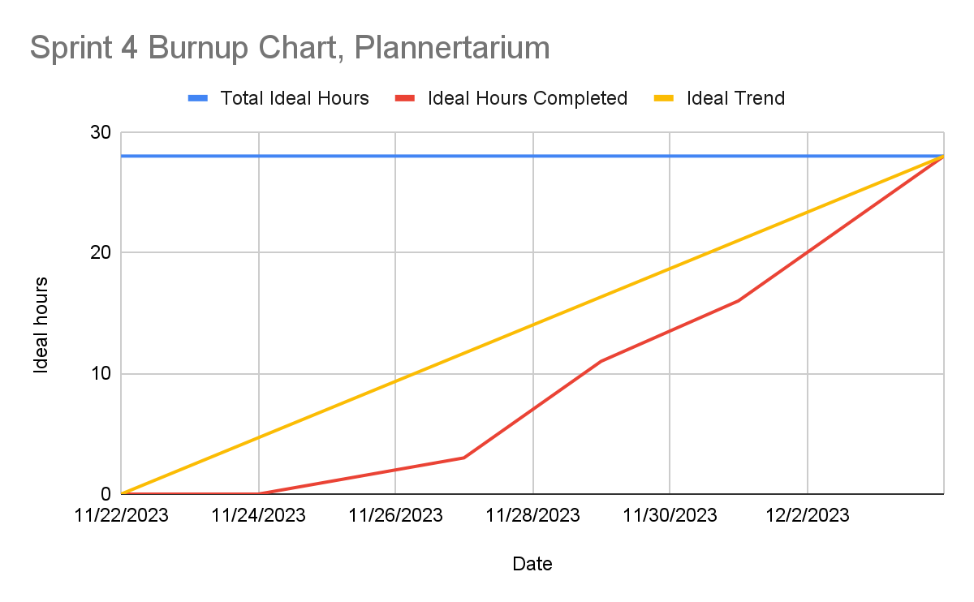

At the beginning, we did not have any tasks completed because of Thanksgiving break. It was a good opportunity to allow our team members to regain their energy. After the break, we started working to gain progress in our user stories. Towards the end of the sprint, we put in much more collective time as a team to work faster and get the user stories done. We ran into many issues at the end of development. Initially we did not have much experience in front end development, so a lot of it was working but designed without modular components following SOLID. When we had a working version of the app with all user stories, and went back to refactor out duplicated code or create new interfaces, it often caused new bugs which we could not detect easily. Fixing these bugs was time consuming and also caused other bugs, and they also often reappeared when we tried to further refactor the code. We should have used a bigger upfront design, but due to our collective lack of experience in frontend, it was not as clean or well designed and dragged us down in the end.

# Completed Scrum Board

